Nama : I’tishom Al Khoiry

NIM : L200150058

Kelas : B

1. Program daftar kode ASCII

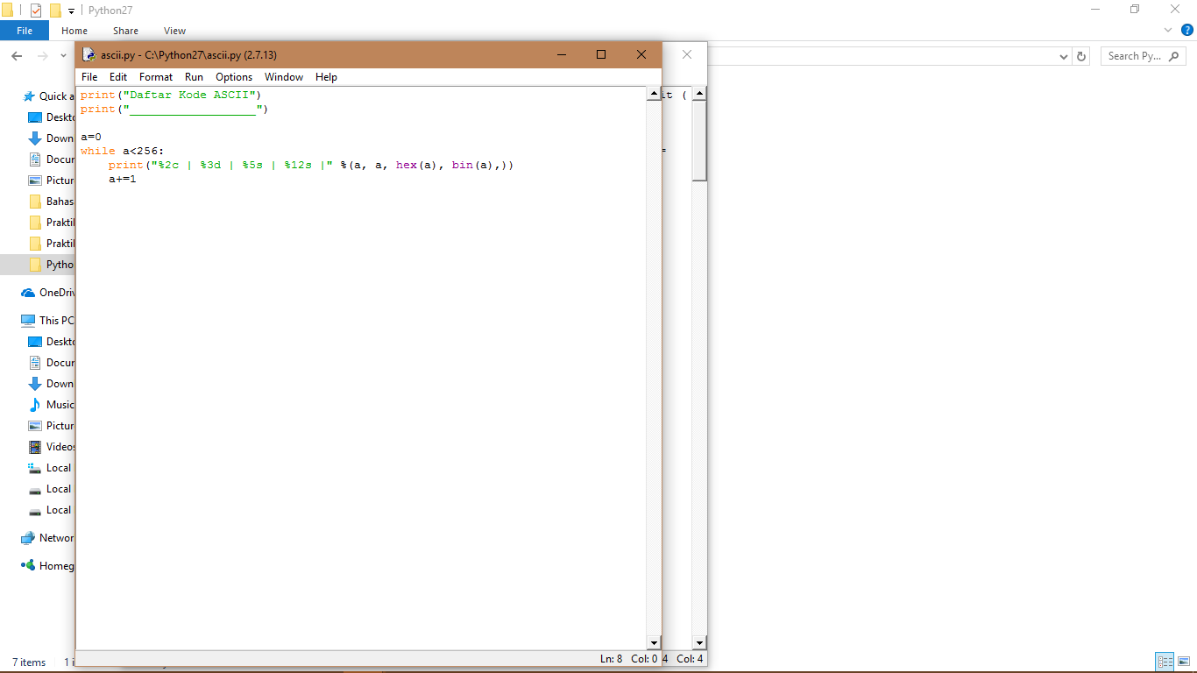

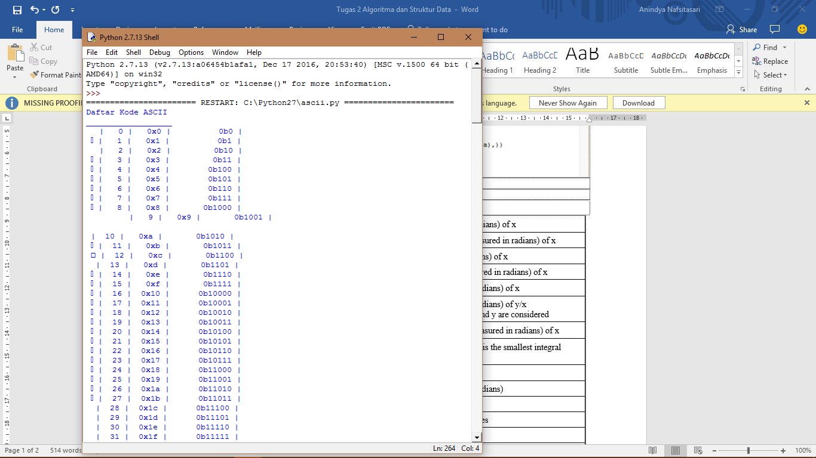

1. Fungsi matematik dalam metode math

|  |  |
| --- | --- |
| acos(...) | Return the arc cosine (measured in radians) of x |
| acosh(...) | Return the hyperbolic arc cosine (measured in radians) of x |
| asin(...) | Return the arc sine (measured in radians) of x |
| asinh(...) | Return the hyperbolic arc sine (measured in radians) of x |
| atan(...) | Return the arc tangent (measured in radians) of x |
| atan2(y, x) | Return the arc tangent (measured in radians) of y/x  Unlike atan(y/x), the signs of both x and y are considered |
| atanh(x) | Return the hyperbolic arc tangent (measured in radians) of x |
| ceil(x) | Return the ceiling of x as a float. This is the smallest integral value >= x |
| copysign(x, y) | Return x with the sign of y |
| cos(x) | Return the cosine of x (measured in radians) |
| cosh(x) | Return the hyperbolic cosine of x |
| degrees(x) | Convert angle x from radians to degrees |
| erf(x) | Error function at x |
| erfc(x) | Complementary error function at x |
| exp(x) | Return e raised to the power of x |
| expm1(x) |  |
| Return exp(x)-1 | This function avoids the loss of precision involved in the direct evaluation of exp(x)-1 for small x |
| fabs(x) | Return the absolute value of the float x |
| factorial(x) -> Integral | Find x!. Raise a ValueError if x is negative or non-integral |
| floor(x) | Return the floor of x as a float. This is the largest integral value <= x |
| fmod(x, y) | Return fmod(x, y), according to platform C. x % y may differ |
| frexp(x) | Return the mantissa and exponent of x, as pair (m, e). m is a float and e is an int, such that x = m * 2.**e. If x is 0, m and e are both 0. Else 0.5 <= abs(m) < 1.0 |
| fsum(iterable) | Return an accurate floating point sum of values in the iterable. Assumes IEEE-754 floating point arithmetic |
| gamma(x) | Gamma function at x |
| hypot(x, y) | Return the Euclidean distance, sqrt(x*x + y*y) |
| isinf(x) -> bool | Check if float x is infinite (positive or negative) |
| isnan(x) -> bool | Check if float x is not a number (NaN) |
| ldexp(x, i) | Return x * (2**i) |
| lgamma(x) | Natural logarithm of absolute value of Gamma function at x |
| log(x[, base]) | Return the logarithm of x to the given base. If the base not specified, returns the natural logarithm (base e) of x |
| log10(x) | Return the base 10 logarithm of x |
| log1p(x) | Return the natural logarithm of 1+x (base e). The result is computed in a way which is accurate for x near zero |
| modf(x) | Return the fractional and integer parts of x. Both results carry the sign of x and are floats |
| pow(x, y) | Return x**y (x to the power of y) |
| radians(x) | Convert angle x from degrees to radians |
| sin(x) | Return the sine of x (measured in radians) |
| sinh(x) | Return the hyperbolic sine of x |
| sqrt(x) | Return the square root of x |
| tan(x) | Return the tangent of x (measured in radians) |
| tanh(x) | Return the hyperbolic tangent of x |
| trunc(x:Real) -> Integral | Truncates x to the nearest Integral toward 0. Uses the __trunc__ magic method |